**A1-1 report**

Baorong Wei, 301401797

alpha (α): Controls the continuity of the snake. Larger values will make the snake act like a rigid rod, while smaller values will make it more flexible.

beta (β): Controls the curvature of the snake. Larger values make the snake smoother, while smaller values allow it to form more intricate shapes.

gamma (γ): The time step in each iteration. It's a balance between accuracy and speed of convergence.

kappa (κ): A coefficient to control the influence of the external energy on the snake.

w_line: Weight of the line energy, which pulls the snake to regions of the image with intensities similar to the snake points.

w_edge: Weight of the edge energy, which attracts the snake to edges in the image.

w_term: Weight of the terminal energy, which might be used to detect corners or end-points.

Star:

alpha *=* 0.05

    beta *=* 2

    gamma *=* 1

    kappa *=* 2

    w_line *=* 0.01

    w_edge *=* 1

    w_term *=* 0.01



circle:

    alpha *=* 0.1

    beta *=* 3

    gamma *=* 1

    kappa *=* 2

    w_line *=* 0.01

    w_edge *=* 1

    w_term *=* 0.01



square:

    alpha *=* 0.05

    beta *=* 0.05

    gamma *=* 1

    kappa *=* 2

    w_line *=* 0.001

    w_edge *=* 1.1

    w_term *=* 1



shape:

    alpha *=* 0.06

    beta *=* 0.6

    gamma *=* 1

    kappa *=* 2

    w_line *=* 0.001

    w_edge *=* 1.5

    w_term *=* 0.5



dental:

    num_interpolated_points *=* 1500  *# Number of interpolated points*

alpha *=* 0.06

    beta *=* 1

    gamma *=* 1.1

    kappa *=* 2

    w_line *=* 0.001

    w_edge *=* 2

    w_term *=* 0.5

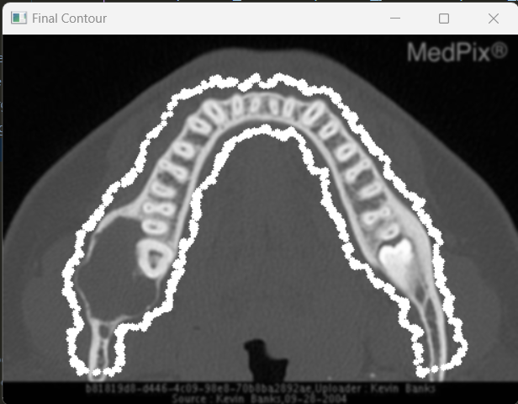

outer layer of the brain (left image below):

    alpha *=* 0.06

    beta *=* 1.2

    gamma *=* 1

    kappa *=* 3.5

    w_line *=* 0.001

    w_edge *=* 2.5

    w_term *=* 0.01

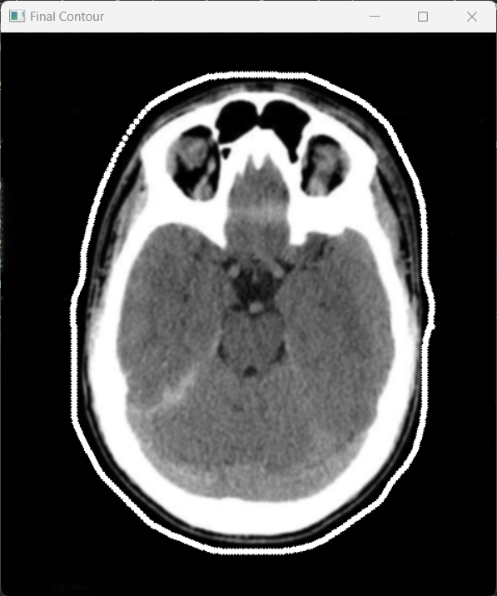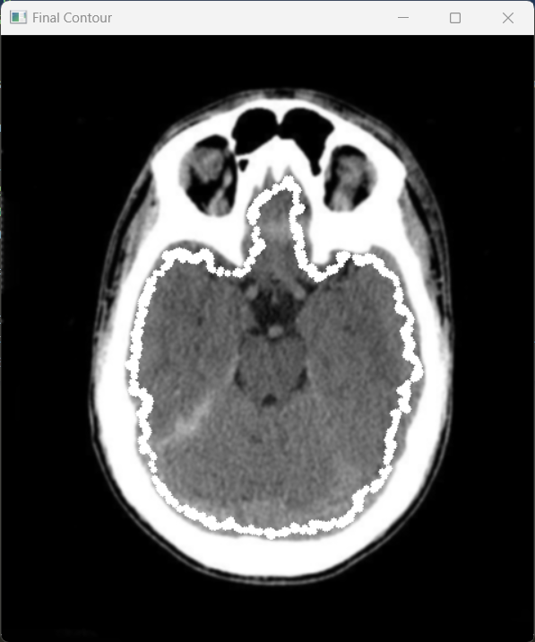

inner contour of the brain (right image above):

    alpha *=* 0.6

    beta *=* 2.5

    gamma *=* 1.5

    kappa *=* 3

    w_line *=* *-*0.001

    w_edge *=* 2.5

    w_term *=* 0.01

right eye hole:

    alpha *=* 0.08

    beta *=* 1.5

    gamma *=* 1

    kappa *=* 2.5

    w_line *=* 1

    w_edge *=* 3

    w_term *=* 0.01

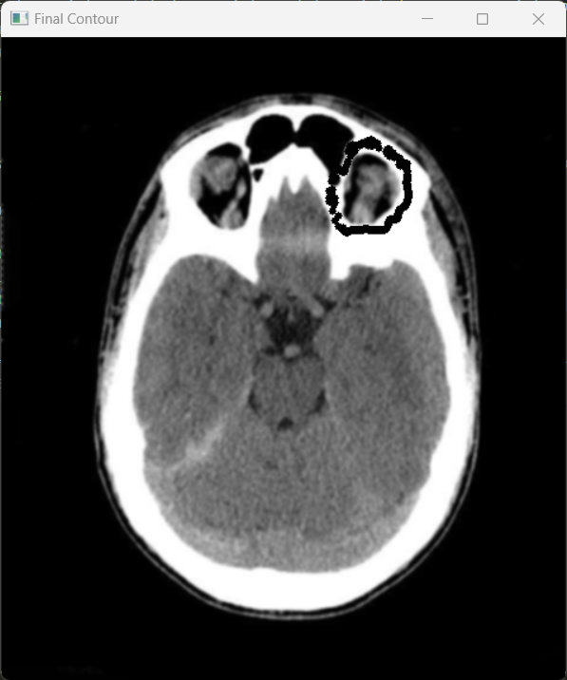

vase:

    alpha *=* 0.2

    beta *=* 2

    gamma *=* 1

    kappa *=* 2

    w_line *=* 0.001

    w_edge *=* 1.2

    w_term *=* 0.5



**Answer to the bonus question:**

Cx and Cy are the first-order derivatives of the image intensity in the x and y directions, respectively. They represent the gradient. Cxx, Cyy, and Cxy are the second-order derivatives (in terms of x and y). The numerator represents the gradient direction, which is the change in intensity of the image, with second-order derivatives. The nominator provides information about the bendiness or the degree of turning of the curve. The denominator acts as a normalizing factor. The first-order derivatives capture the square of the slope of the curve at a point. It adjusts or scales this information based on the steepness or the gradient of the curve.